Artificial Intelligence (AI) in Healthcare & Medical Field

Shrankhla Saxena¹(corresponding author)
IET-CSE , Mangalayatan University, Aligarh, India. sxn.shr@gmail.com
Javed Wasim²
IET, Faculty of Engineering & Sciences, Mangalayatan University, Aligarh, India. javed.wasim@managalayatan.edu.in
Abhinav Juneja³
Computer science & information technolgy, KIET group of institutions, Ghaziabad, India. abhinav.juneja@kiet.edu

ABSTRACT: Different technologies are adopted and experimented with increasing automation in the medical field. Now a day, AI is being introduced in the medical field to keep a medical record in digital format and conduct patient checkup using smart technologies. It provides solutions, especially in targeted treatments, uniquely composed drugs and personalized therapies. AI is an innovative technology that helps to guide the surgeon during medication, treatment and operation. The main application of this technology is for better decision making for complicated cases. It can also help to track, detect, investigate and control the infection in the hospital. This technology develops and optimized online patient appointment platform. In future, it will helpful in all medical areas to serve humanity.
Keywords: Test case prioritization, Genetic algorithm, Machine learning.

Introduction
In the current scenario, AI seems the best technology which can be used for providing higher life expectancy. It provides AI-assisted robotic surgery for a complicated case. This technology creates information through different virtual support and regularly communicates with the patient. In rural areas, there is a shortage of healthcare providers and this technology can be gainfully employed to fulfil this shortage. It improves the quality of medical students to fulfil any urgent demand for rural areas8,9. This technology not only improves the efficiency of health professionals but also improves the quality of healthcare service at a lesser cost. It provides advice to doctors towards accurate diagnosis10,11.
Artificial Intelligence plays a significant role in scanning technologies like X-rays, Computed Tomography (CT), Magnetic Resonance Imaging (MRI) and 3D scanners. These are helpful to make a better decision regarding the patient. AI suggests proper diet and eating habits for better health. It efficiently manages patient booking and reminds about doctor’s appointment12-14. This technology is also helpful in virtual interaction with doctors and with its deployment, the medical field becomes efficient to solve various challenges
.

Background and Related work
The goal of prioritizing the test cases is to sort test case as per their priority so that maximum faults can be detected in less time hence decreasing the cost of regression testing also. Since, testers need to run the test cases first to know the fault detection efficiency of any TCP technique, therefore researchers have proposed various coverage- based metrics for test case prioritization. Researchers have distributed coverage-based TCP methods into two main classes- metrics for white box and black box. White box coverage metrics mainly include statement coverage, block coverage, branch coverage, function coverage etc. Researchers have also proposed various methods for black box coverage metrics such as t-wise technique, calculated diversity of inputs with help of NCD, Jaccard distance, Levenshtein distance etc. After selecting criteria for prioritization for most of the above-mentioned methods, test cases are sorted by greedy algorithm.
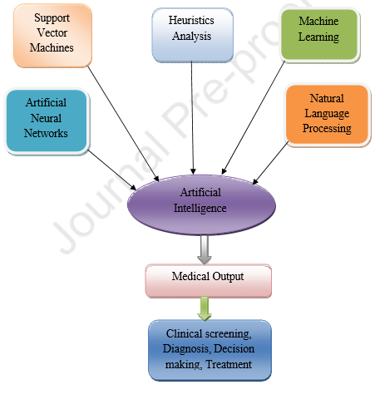

Figure 1. Methodology of TCP Technique

Luo et al. [4] performed study on many real-world programs to analyze TCP techniques and provides some important observations and results. This study includes two metrics of effectiveness which are average percentage faults detected (APFD) and cost-cognizant APFDc. Researchers in this study used dynamic techniques for TCP using statement level coverage and found that static techniques are better and give better results while using APFDc. Their results are based on study and comparison of four static TCP methods which are call graph based method, string distance based method, topic model based method with four dynamic TCP methods which includes total greedy, additional greedy, adaptive random and search based methods. Their results show that values of APFDc and APFD are more consistent at the level of test class than the level of test method.
Khatibsyarbini et al. [6] performed review of 110 papers and found the recent trends in machine learning(ML) for test case prioritization(TCP). This paper represents the increasing use of ML for TCP since 2004. They also found that after 2004 some new ML approaches have been introduced for TCP. ML taxonomy for TCP is given in figure 2.
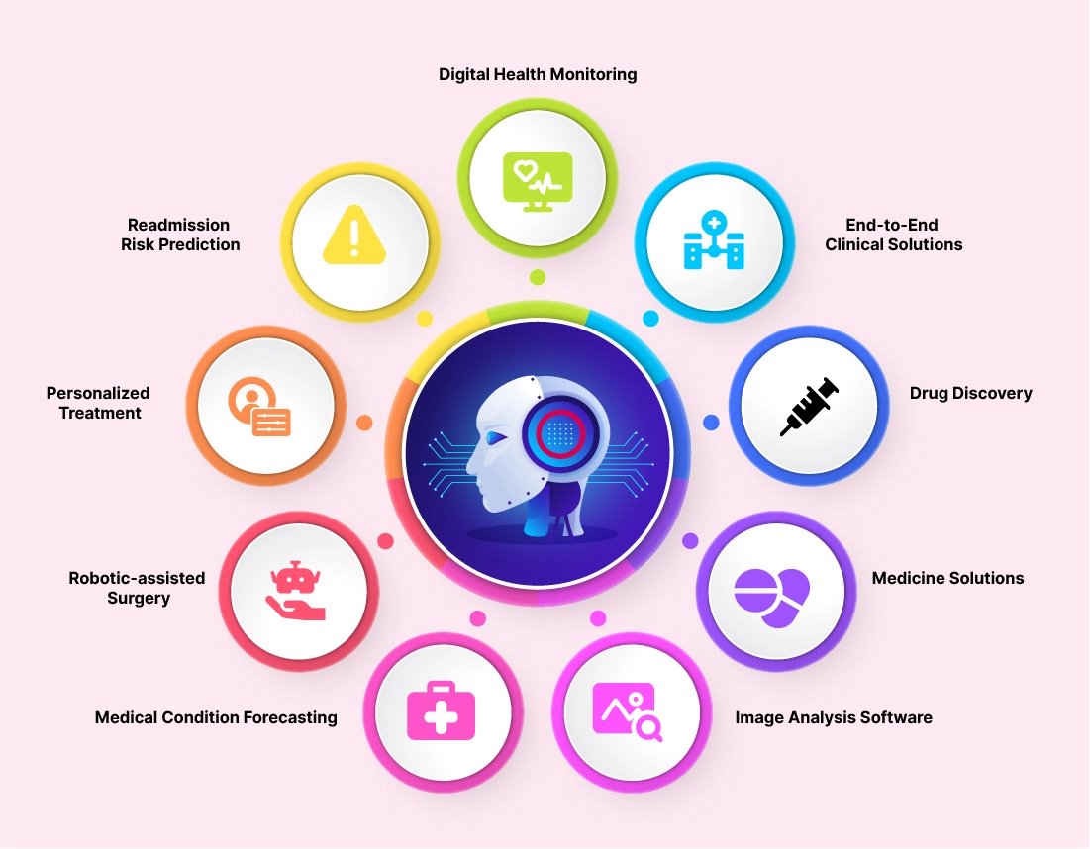

Figure 2. Taxonomy of Machine Learning

After review of 110 papers, it was found that classification techniques have been mostly used ML techniques for TCP. In classification methods K nearest neighbor and decision tree are most popular techniques. In regression techniques, linear regression, regression trees and support vector machine (SVM)

Test Case Prioritization using Genetic Algorithm(GA)
Genetic algorithm is an evolutionary approach of ML which is inspired by the rule of nature i.e. survival of the fittest[7]. It is a heuristic search method which is used to solve optimization problem in ML i.e. problems which need long time to solve. Process of Genetic algorithm is given in figure 5.

Hypervolume Indicator
Hypervolume indicator is mostly used in evolutionary multiple objective optimization[11]. It can measure the amount of the affected portion of the work space. It includes the most dominating features of pareto front. The role of hypervolume indicator is to direct the search in multiple objective optimization and evaluate its performance. Problems of multiple objective optimization are converted to single objective optimization with the help of hypervolume indicator, since it finds the finite number of solutions and increases the hypervolume parameter[10].

6. Results
Artificial intelligence can help to monitor and proper treatment for patients. It makes an assessment in image/result without the requirement of doctors, surgeon and clinician. AI-based technologies provide decision which can help to predict medical emergencies. It is helpful to provide medical consultation through a digital app. The practical implication of this technology is to increase accuracy in diagnosis and treatment. It can be used in the prevention of disease and reduce medical cost.

7. CONCLUSION AND FUTURE SCOPE
This technology is used to answer patient questions and reduce unnecessary hospital visits. AI provides an excellent source and identifies problems during the shortage of doctor. This technology first understands the biological origin of disease for better treatment of the patient. It easily imagines medical images and accurately performs the task. AI helps identify cancer and its treatment with the analysis of patient data. Its applications are for the diagnosis of heart disease. It speeds up the clinical trials to produce a conclusive result. AI constructs analytical algorithms of different features from the patient data, which is helpful to provide information about the patient, survival times and diseases level. In upcoming years, its applications will be for digital supervision in hospitals to improve patient care.

Table 1. comparison of HGA with other ML techniques

S  No | Technologies | Description | References
1 | Recording and storage of medical data | - It collects, stores and analyses the medical data to provide faster access and decision making  - Every patient data is electronically stored which facilitates diagnosis and treatment  - Provide day to day improvement history of the patient  - Data stored digitally can help to identify the cause of diseases and help research and development activity  - It records the all medical record of an individual  patient and further compares the database of illness | [61-65]
2 | Analyze different test | - Artificial intelligence accurately analyse different tests like X-ray, ultrasound, MRI and CT scan  - Capability to check the improvement and significant causes of the disease  - Quickly shares patient information in the emergency case which makes doctors and surgeon job easy  - Efficiently perform, evaluate, validate, predict and analyse the data using different scanning  technologies | [66,67]
3 | Patient monitoring | - It helps to monitor patient condition and follow up all treatments  - Provide proper monitoring to get more exercise, needs and habits of the patient  - Helps in monitoring and access information of the | [68,69]

References
[1] D Nucci, D., Panichella, A., Zaidmain, A. and De Lucia, A. 2020. “A Test Case Prioritization Genetic Algorithm Guided by the Hypervolume Indicator,” in IEEE Transactions on Software Engineering, vol. 46, no. 6, pp. 674-696, doi:10.1109/TSE.2018.2868082.
[2] Bagherzadeh, M., Kahani, N. and Briand, L. 2022. “Reinforcement Learning for Test Case Prioritization,” in IEEE Transactions on Software Engineering, vol. 48, no. 8, pp. 2836-2856, doi: 10.1109/TSE.2021.3070549.
[3] Lachmann, R., Schulze, S., Nieke, M., Seidl, C. and Schaefer, I. 2016. “System-Level Test Case Prioritization Using Machine Learning,” 15th IEEE International Conference on Machine Learning and Applications (ICMLA), Anaheim, CA, USA, 2016, pp. 361-368, doi: 10.1109/ICMLA.2016.0065.
[4] Luo, Q., Moran, K., Zhang, L. and Poshyvanyk, D. 2018. “How Do Static and Dynamic Test Case Prioritization Techniques Perform on Modern Software Systems? An Extensive Study on GitHub Projects,” in IEEE Transactions on Software Engineering, vol. 45, no. 11, pp. 1054-1080, 1 Nov. 2019, doi: 10.1109/TSE.2018.2822270.
[5] Satpathy, S., Khalaf, O. I., Shukla, D. K., Algburi, S., & Hamam, H. (2024). Consumer electronics based smart technologies for enhanced terahertz healthcare having an integration of split learning with medical imaging. Scientific Reports, 14(1), 10412.
[6] Khatibsyarbini, M., Isa, M. A., Jawawi, D. N. A., Shafie, M. L. M., Wan-Kadir, W. M. N., Hamed, H. N. A., Suffain, M. D. M. 2021 “Trend Application of Machine Learning in Test Case Prioritization: A Review on Techniques, “in IEEE Access, vol. 9, pp. 166262-166282, doi:10.1109/ACCESS.2021.3135508.
[7] Sabharwal, S., Sibal, R. & Sharma, C. 2014. Applying Genetic Algorithm for Prioritization of Test Case Scenarios Derived from UML Diagrams., Int J Comput Sc Issues. 8.
[8] Bajaj, A. and Sangwan, O. P. 2019. “A systematic literature review of test case prioritization using genetic algorithms,” in IEEE Access, vol. 7, pp. 126355-126375, doi: 10.1109/ACCESS.2019.2938260.
[9] Deb, K., Pratap, A., Agarwal, S. and Meyarivan, T. 2002. “A fast and elitist multiobjective genetic algorithm: NSGA-II,” in IEEE Transactions on Evolutionary Computation, vol. 6, no. 2, pp. 182-197, doi: 10.1109/4235.996017.
[10] Anne, A., Johannes, B., Dimo, B. and Eckart, Z. 2009. Theory of the Hypervolume Indicator: Optimal µ-Distributions and the Choice of the Reference Point. Proceedings of the 10th ACM SIGEVO Workshop on Foundations of Genetic Algorithms, FOGA’09. 10.1145/1527125.1527138.

